11.1 Reversible reaction
Name: ____________________ Class: ____________________ Due date: 4.17
1. Which reaction is not a reversible reaction? （ ）
A combustion of alkanes
B hydration of anhydrous copper(II) sulfate
C melting lead(II) bromide
D thermal decomposition of hydrated cobalt(II) chloride

2. Which terms describe the pink cobalt(II) chloride and the reaction? （ ）
 | pink cobalt(II) chloride is | the reaction is reversible
A | anhydrous | yes
B | anhydrous | no
C | hydrated | yes
D | hydrated | no

3. The equation shows the formation of anhydrous copper(II) sulfate from hydrated copper(II) sulfate.
$$CuSO_{4} ∗5H_{2}O⇌CuSO_{4}+5H_{2}O$$
Statements 1, 2 and 3 refer to this reaction.
1 Hydrated copper(II) sulfate is reduced to anhydrous copper(II) sulfate.
2 The (II) in the name copper(II) sulfate refers to the oxidation state of the metal.
3 The reaction is reversible.
Which statements are correct? （ ）
A 1 only B 1 and 2 C 2 and 3 D 3 only
5. The diagram shows the change from an anhydrous salt to its hydrated form.
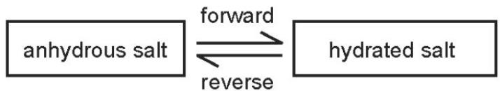
Which statement is correct? （ ）
A forward reaction requires heat and water
B forward reaction requires water only
C reverse reaction requires heat and water
D reverse reaction requires water only
6. Solid copper(II) sulfate can exist in two different forms, anhydrous and hydrated.
One of these forms is blue and the other is white.
The change between these two forms is reversible.
blue form ⇌ white form
Which is the blue form and how is the change from the blue form to the white form brought about? （ ）
 | blue form | change to white form
A | anhydrous | add water
B | anhydrous | heat
C | hydrated | add water
D | hydrated | heat
7. Heating pink cobalt(II) chloride crystals forms a blue solid and steam.
The blue solid turns pink when water is added.
.The equation shows a reaction that is reversed by changing the conditions.
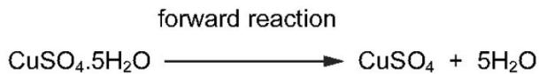
How can the forward reaction be reversed? （ ）
 | by adding water | by heating
A | ✓ | ✓
B | ✓ | ×
C | × | ✓
D | × | ×
8 Separate samples of anhydrous and hydrated copper(II) sulfate are heated.
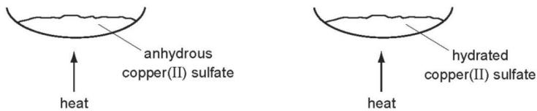
Which shows the correct colour changes? （ ）
 | anhydrous copper(II) sulfate | hydrated copper(II) sulfate
A | blue to white | white to blue
B | no change | blue to white
C | white to blue | blue to white
D | white to blue | no change
9. Some crystals of hydrated cobalt(II) chloride are heated in a test- tube until no further change is observed.
The test- tube is allowed to cool and a few drops of water are then added to the contents.
Which colours are observed? （ ）
 | before heating | after heating | after adding water
A | blue | pink | blue
B | blue | white | blue
C | pink | blue | pink
D | white | blue | white

10. Nitrogen, hydrogen and ammonia gases are placed inside a container.
The container is then sealed. After some time, an equilibrium forms.
$$N_{2}(g)+3H_{2}(g)⇌2{NH}_{3}(g)$$
Which statement describes the equilibrium in this container? （ ）
A The amount of ammonia remains constant from the moment the container is sealed.
B The amounts of ammonia, nitrogen and hydrogen in the container are always equal.
C The rate of formation of ammonia is equal to the rate of decomposition of ammonia.
D The rate of formation of ammonia is faster than the rate of decomposition of ammonia.

11.The reaction used to manufacture ammonia from nitrogen and hydrogen is reversible.
An equilibrium can be established between ammonia, nitrogen and hydrogen.
Which statement describes the equilibrium? （ ）
A Both the forward reaction and the backward reaction have the same rate.
B The rate of the backward reaction is greater than the rate of the forward reaction.
C The rate of the forward reaction is greater than the rate of the backward reaction.
D The forward and backward reactions have both stopped.

12. Ammonia is manufactured by the Haber process.
a.The equation for the reaction is shown.
$$N_{2}(g)+3H_{2}(g)⇌2{NH}_{3}(g)$$
i.State what is meant by the symbol $⇌$
13. Ammonia is also made when ammonium carbonate decomposes.
$$({NH}_{4})_{2}{CO}_{3}(s)⇌2{NH}_{3}(g)+H_{2}O(g)+{CO}_{2}(g)$$
The reaction is reversible and can reach a position of equilibrium.
The graph shows how the yield of ammonia at equilibrium changes with temperature and pressure.
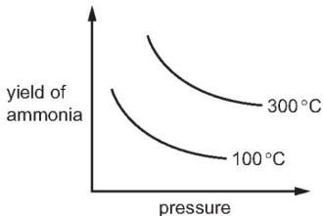
i.What is meant by the term equilibrium for a reversible reaction?
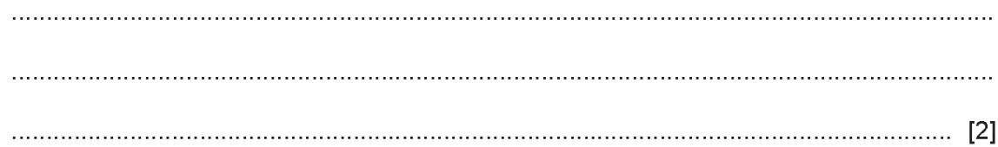
(ii)Describe two features of an equilibrium.
..................................................................................................................................
..................................................................................................................................

